# These instructions are for linking your ALEKS account to your D2L account

To start go into the Course Admin Section of your D2L course and find import and export components

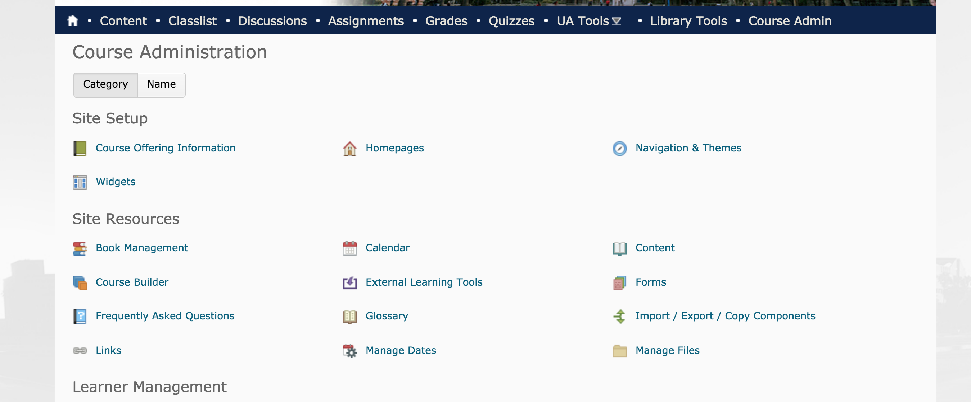

Select search for offering

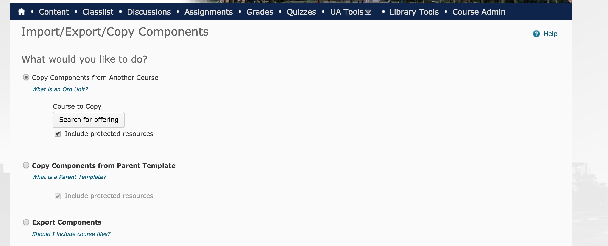

Search for Math 112

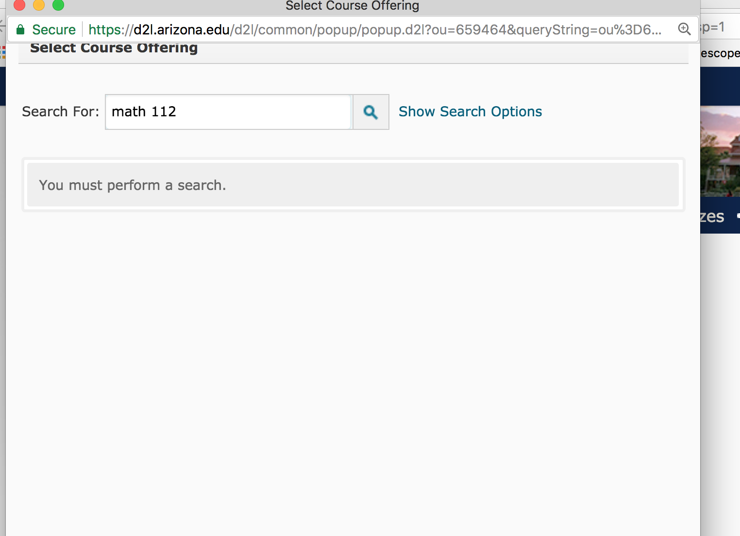

A screen similar to this will come up, select **Math 112 Regular Delivery Baseline** and click on Add Selected

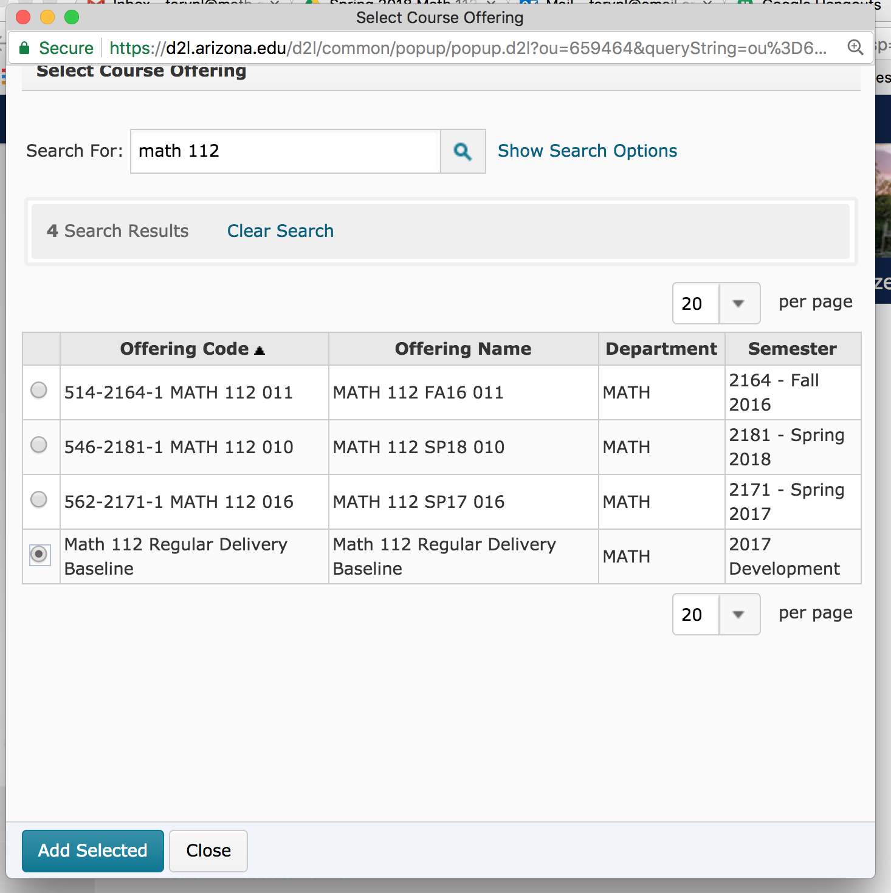

Select copy all components

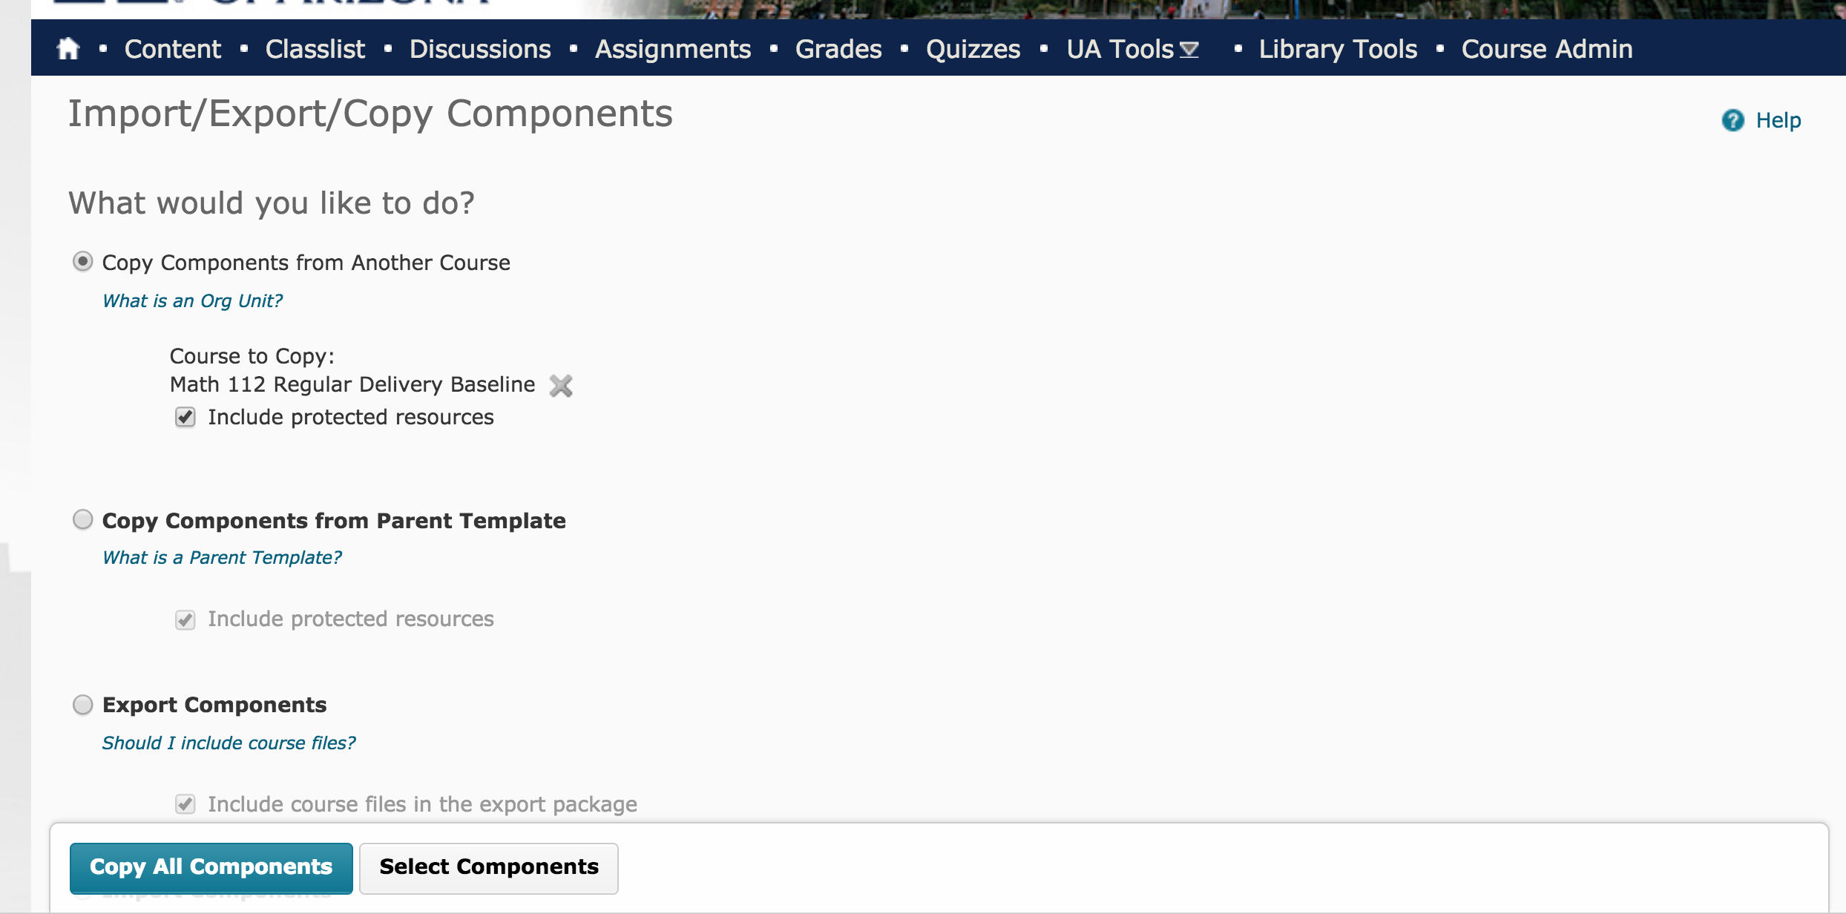

Now go to content, select ALEKS and click on the link

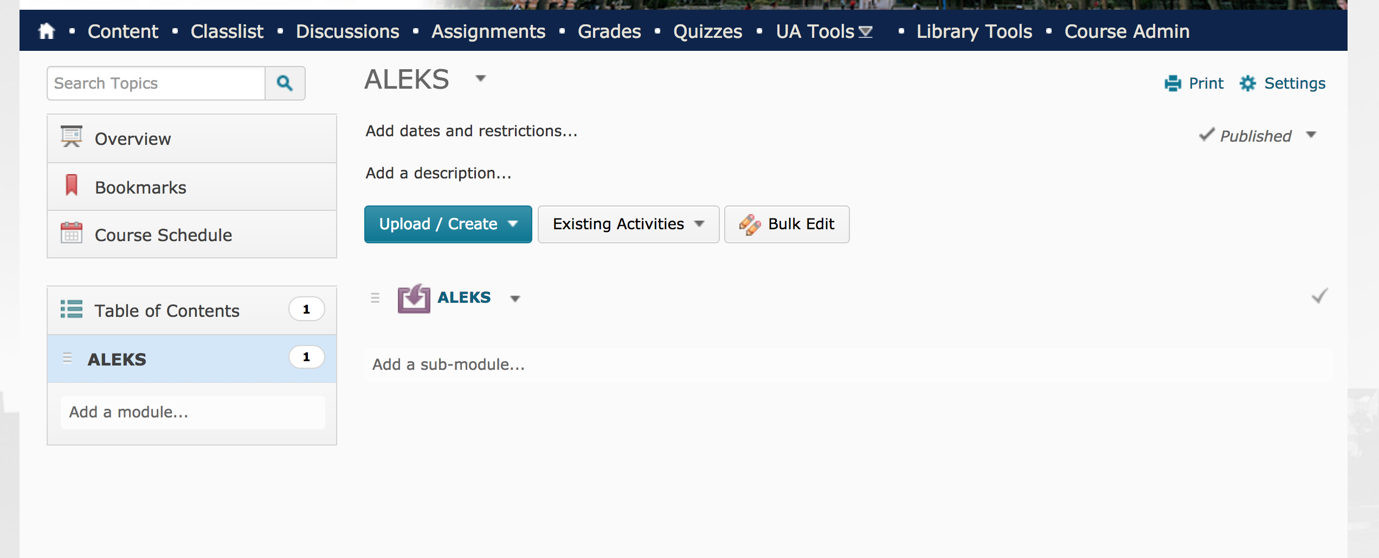

A screen like this will appear, click on **Yes, I want to use my existing ALEKS account** and sign in using your user name and password

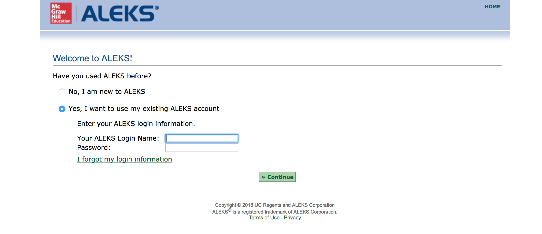

This screen appears, but **You are not done yet!** Click **Continue.**

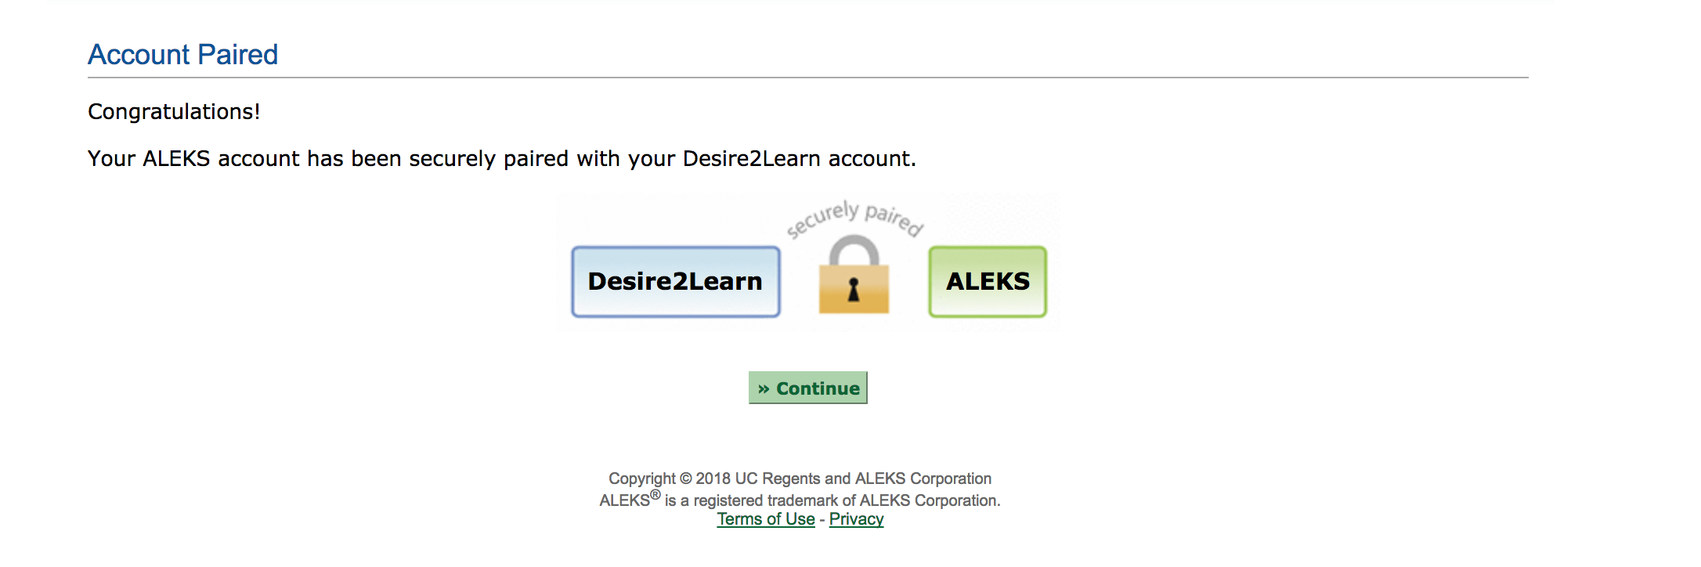

Find the option that says **An Existing ALEKS Class** and then select the following:

Instructor: My Classes

Class: Math 112 – (Your section number)

Click on Continue

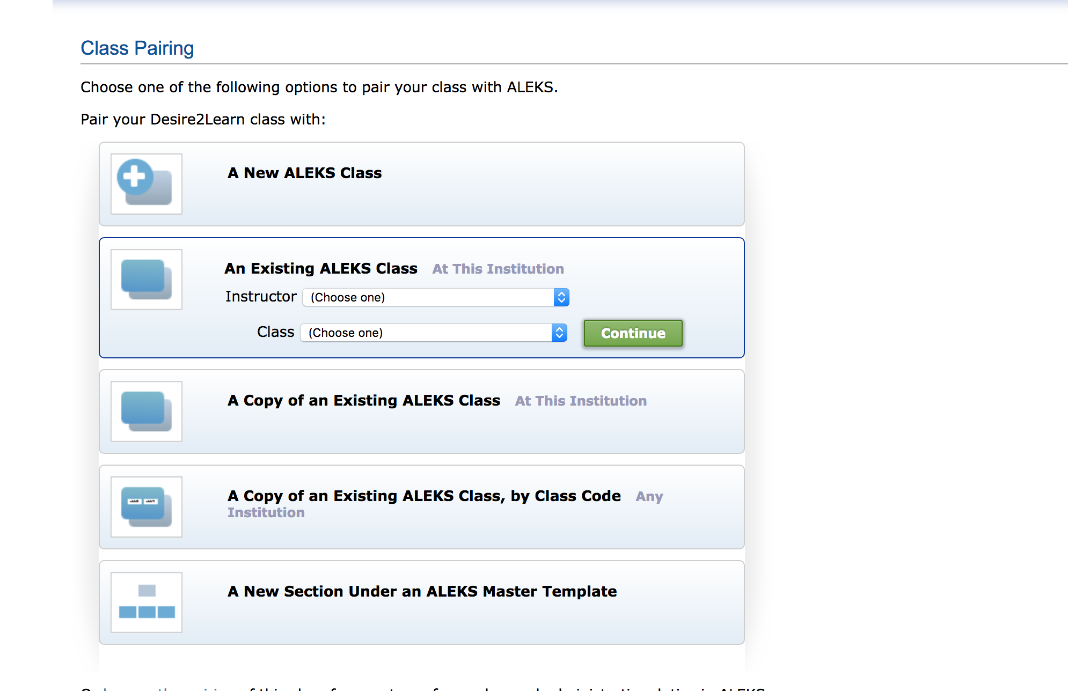

Now click continue and you are done.

